

**PLACEMENT MANAGEMENT SYSTEM**

DBMS PROJECT



By

ABINASH ANKIT RAUT (14CS01012)

K ANANTH (14CS01018)

**The project involved designing a database along with its frontend and backend components to facilitate placements in the institute. The placement database management project has been made to give various access for different type of users i.e. students, administrator or placement officer and companies. Every user has his own limited set of features. The project involves use of various web and database technologies namely HTML, CSS, PHP, MySQL, etc.**

Introduction

Requirements

For Users:-

* Internet Connectivity
* Web Browser (Google Chrome, Mozilla Firefox for better experience).

For Administrator:-

* Apache Server – to host
* phpmyadmin root access
* MySQL knowledge
* Internet Connectivity
* Web Browser (Google Chrome, Mozilla Firefox for better experience).

Tools Used:-

* Frontend: HTML, CSS, Javascript, Jquery
* Backend: PHP, MySQL
* Software: Xampp

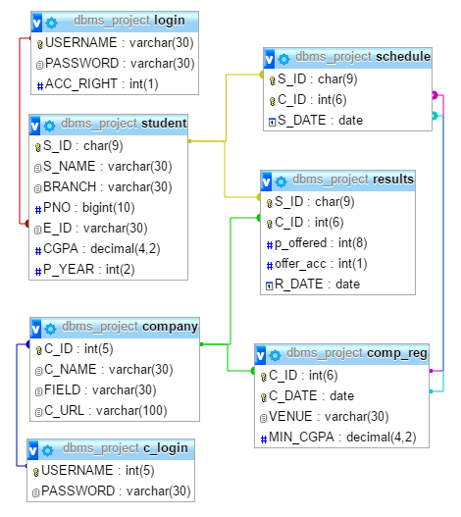

Relational Model Design

Applications and Features

* Student Sign-up and Log-in.
* Company Log-in.
* Company sign-up, registration done by database administrator (Placement Officer).
* History containing yearly company statistics (Average Package, No of Students Selected).
* Everyone can see the Placement History.
* A Student can register in companies visiting his institute in his passing year and in which he/she is eligible to.
* A Student can deregister from company before commencement of the interview.
* Student can change his details (Phone no, passing year, CGPA).
* Repeating Students (can change their passing year) previous placement related data are deleted.
* Students can view available offers. Can accept only one.
* Company can see students willing to appear for the interview.
* Company can offer placement to student after interview.
* Company can view list of students who accepted the offer.
* Company can view list of students who are yet to accept the offer.

Triggers details

* COMP_REG_CHECK
  + To make sure company selects dates for interview within the present placement season.
* SC_CHECK
  + Check the student registering is eligible for the company based on company criteria (CGPA).
  + To ensure a student who has already accepted an offer cannot appear for any more interviews.
  + To make sure the final year student registers for the company coming to the college in that particular academic year.
* OFF_ACC_CHECK
  + To make sure student accepts the offer only during the current placement season.
* OFF_CHECK
  + To ensure company gives offer to any student only after interview process.
* DEL_YR_CHG
  + To enable a repeating student to upgrade his passing year by resetting his placement records.
* COMP_ID_CHECK
  + To ensure the company gets a valid id based on the current academic year.
* RES_ACC_CHECK
  + To delete all the previous schedules for a student when he accepts any offer.

Event Scheduler detail

* C_DELETER
  + Deletes all the company registration records and obsolete schedule records at the end of placement season.

Limitations

And

Future Work

* Limitations
  + Unavailability of University database lead to reduction of features.
  + More secure and consistent student login can be ensured by making student s_id as referential attribute to university database student table.
  + More company requirements can be added by using university database.
  + The website is presented in a local server which limits its accessibility.
  + Multiple Round interview are not allowed.
* Future Work
  + Multiple round interview can ensured.
  + A recommendation system for students which recommends them the companies in which they are most likely to be selected based on previous years statistical data.
  + Integrating the placement database with university database to add a whole new range of features.
  + More user friendly access through mobile apps and windows applications.